Blue Star Programme
Castlegar National School
2014

Report

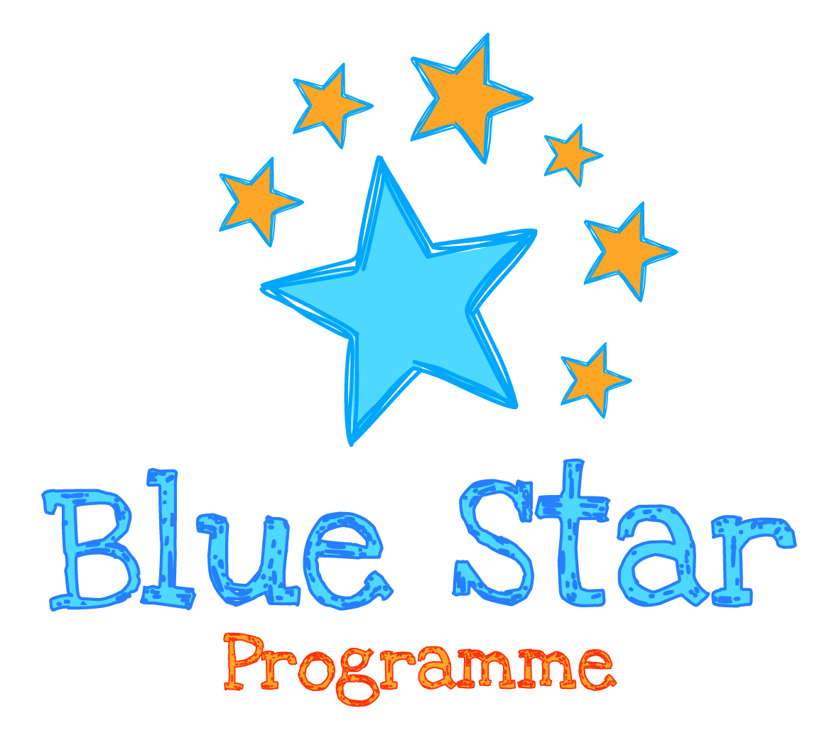
Report
The following areas have been the main core elemnts of our Blue Star Programme which Castlegar National School throughly enjoyed.

- Historical

For the historical section of the Blue Star Programme, we explored the Holocaust and paid particular focus on the life of Anne Frank. We integrated literacy into our project through the use of the book “The Diary of Anne Frank”.

We carried out a whole class project on Anne Frank and presented it in both slideshow and hardcopy form on a display board for all children in our school to view and discuss together.

The children really enjoyed this section and have deepened their knowledge in relation to this fascinating and thought provoking era in history.

**Photographs attached at end of this document of all project work carried out in our school.

- Geographical
The geographical section of our project included the creation of a booklet. The booklet consisted of a variety of factfiles of other EU countries. Each factfile included:
- Capital City
- Populations
- Famous monuments
- Rivers, Mountains and Lakes
The children also carried out individual oral reports on their chosen country, which they presented to the class. *Photographs attached at end

We picked France as the EU country which we compared and contrasted to Ireland. We focused on a variety of aspects including:

- Food
- A typical school day
- Pastimes
- Festivals celebrated

- Cultural & Creative
We learned the EU Anthem and sang it with a number of instruments that come from a varirty of EU countries.

We invited visitors from different EU countries (Parents from Poland etc) into our school to speak to us about life in their particular country.

A number of questions were prepared for them before they arrived. The classroom was designed with flags from the particular countries for their arrival.

The children really enjoyed this day as it gave them a greater insight into other EU countries and enavled them to appreciate things in Ireland that outher EU countries don’t have.

- Institutional
For this particular section we created a questionaire for a local MEP (Marian Harkin) and invited her into our school on April 7th to speak with us about the role of the European Parliament and the European Commission which we had previously explored in class. We also wathched a DVD ‘Ireland and the European Union’ a few weeks previous.

We compiled a Blue Star Programme Folder which has all the resources we used and the notes we took from the day.

The children really enjoyed the visit and were very inquisitive of Marian’s role and how they could follow in her footsteps.

- Europe Day Celebrations
We held an EU day on May 9th where the children participated in a variety of work station activities. We had eight activities set up in the classroom. The following activities were carried out in the various stations:

- Languages
(Can you match the language and the country?)
- Culture
- Food
- Flags
- Famous Monuments
- Rivers,Lakes and Mountains
- Capitals etc.
A game of “Who wants to be a millionaire” was carried out.
The overall winners of the station activities and the ‘Who wants to be a millionaire?’ game received prizes.

Project Stands
The children also set up a stand for their country in the classroom. We invited 3rd and 4th class children into our room where they were encouraged to ask questions and sample some of the exotic food that the children had cooked/bought to represent their country.
*Please find attached a number of photographs to coincide with all core elements of our project. Furthermore, feel free to visit our school to view our large Blue Star Folder that we complied throughout the last few months.

Anne Frank Display
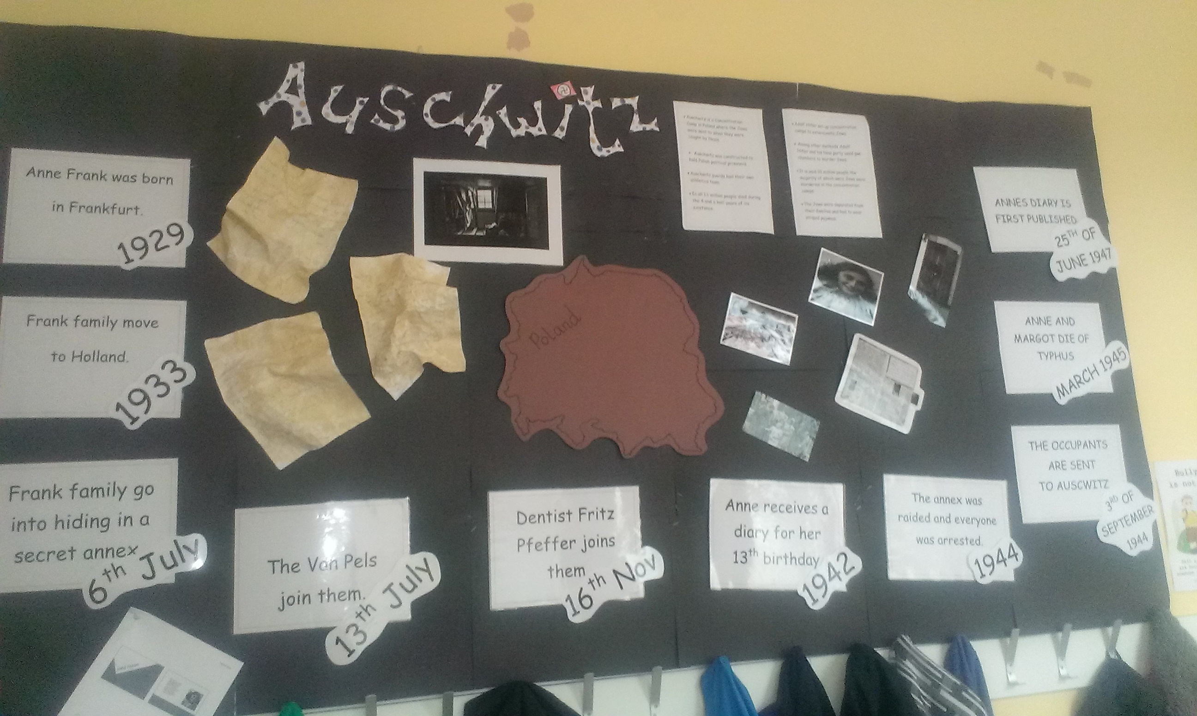

*Powerpoint Attached also

Europe Day Photos
*Here are a sample of photos from May 9th 2014
Station Work
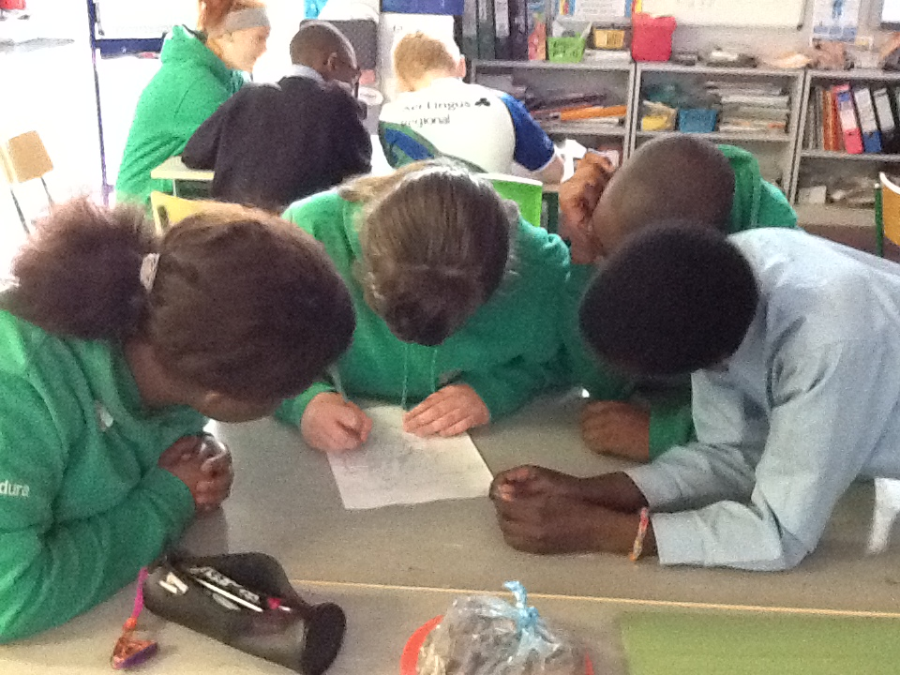
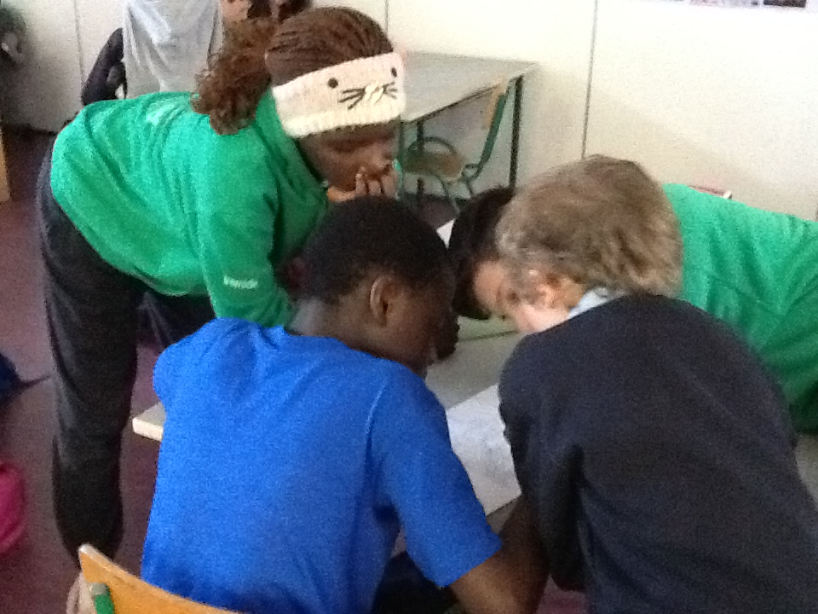

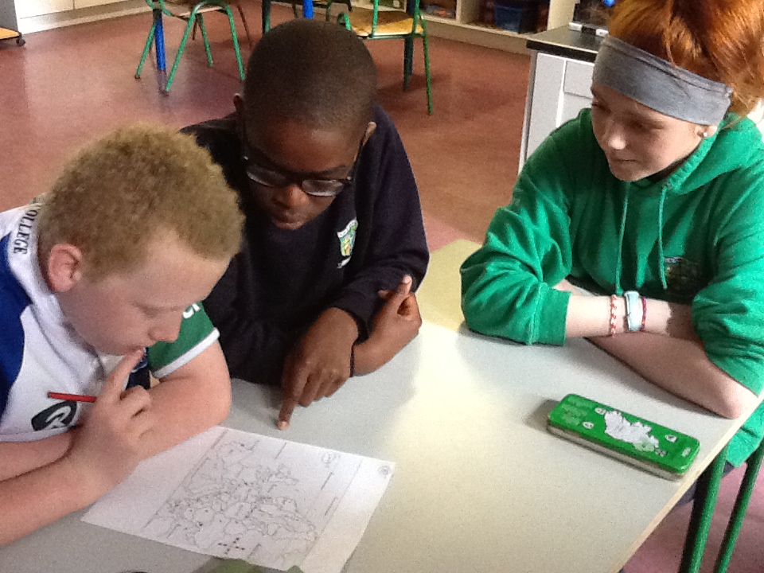

Individual Project Work – EU Countries

